***Creating Collection***

db.createCollection("Member")

db.Member.insert

(

[

{

"member_id" : "1",

"member_fname" : "Akshul",

"member_lname" : "Agarwal",

"member_insurance_status" : "1",

"relation" : "Self",

"sub_id" : "1",

"group_id" : "1",

"primary_doctor" : "1",

count : NumberInt(0)

},

{

"member_id" : "2",

"member_fname" : "Gaurang",

"member_lname" : "Panchal",

"member_insurance_status" : "1",

"relation" : "Group Member",

"sub_id" : "1",

"group_id" : "1",

"primary_doctor" : "1",

count : NumberInt(0)

},

{

"member_id" : "3",

"member_fname" : "Ujjval",

"member_lname" : "Thakkar",

"member_insurance_status" : "1",

"relation" : "Group member",

"sub_id" : "1",

"group_id" : "1",

"primary_doctor" : "2",

count : NumberInt(0)

},

{

"member_id" : "4",

"member_fname" : "John",

"member_lname" : "Doe",

"member_insurance_status" : "1",

"relation" : "Group member",

"sub_id" : "1",

"group_id" : "1",

"primary_doctor" : "2",

count : NumberInt(0)

},

{

"member_id" : "5",

"member_fname" : "Peter",

"member_lname" : "Samson",

"member_insurance_status" : "1",

"relation" : "Self",

"sub_id" : "2",

"group_id" : "2",

"primary_doctor" : "3",

count : NumberInt(0)

},

{

"member_id" : "6",

"member_fname" : "Harry",

"member_lname" : "Potter",

"member_insurance_status" : "1",

"relation" : "Group member",

"sub_id" : "2",

"group_id" : "2",

"primary_doctor" : "3",

count : NumberInt(0)

},

{

"member_id" : "7",

"member_fname" : "Charles",

"member_lname" : "Rhodes",

"member_insurance_status" : "1",

"relation" : "Group member",

"sub_id" : "2",

"group_id" : "2",

"primary_doctor" : "4",

count : NumberInt(0)

},

{

"member_id" : "8",

"member_fname" : "Nick",

"member_lname" : "Halden",

"member_insurance_status" : "1",

"relation" : "Group member",

"sub_id" : "2",

"group_id" : "2",

"primary_doctor" : "4",

count : NumberInt(0)

},

{

"member_id" : "9",

"member_fname" : "Dan",

"member_lname" : "Summers",

"member_insurance_status" : "1",

"relation" : "Self",

"sub_id" : "3",

"group_id" : "3",

"primary_doctor" : "5",

count : NumberInt(0)

},

{

"member_id" : "10",

"member_fname" : "Steve",

"member_lname" : "Harvey",

"member_insurance_status" : "1",

"relation" : "Group member",

"sub_id" : "3",

"group_id" : "3",

"primary_doctor" : "5",

count : NumberInt(0)

},

{

"member_id" : "11",

"member_fname" : "Jack",

"member_lname" : "Reacher",

"member_insurance_status" : "1",

"relation" : "Self",

"sub_id" : "4",

"group_id" : "4",

"primary_doctor" : "6",

count : NumberInt(0)

},

{

"member_id" : "12",

"member_fname" : "Bill",

"member_lname" : "Gates",

"member_insurance_status" : "1",

"relation" : "Group member",

"sub_id" : "4",

"group_id" : "4",

"primary_doctor" : "7",

count : NumberInt(0)

},

{

"member_id" : "13",

"member_fname" : "Mathew",

"member_lname" : "Hayden",

"member_insurance_status" : "1",

"relation" : "Group member",

"sub_id" : "4",

"group_id" : "4",

"primary_doctor" : "9",

count : NumberInt(0)

}

]

)

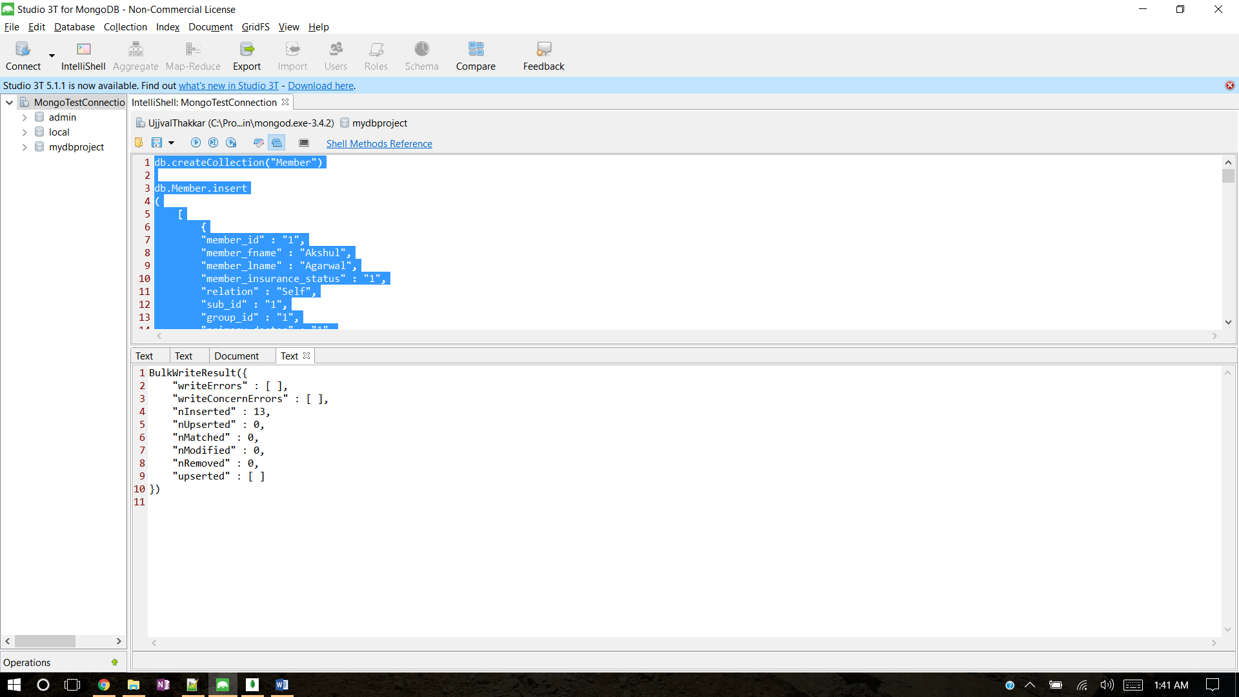

***Search through the Members in your mongo collection and return a document based on searching for a name***

db.Member.find(

{"Member_fname":"Ujjval"}

)

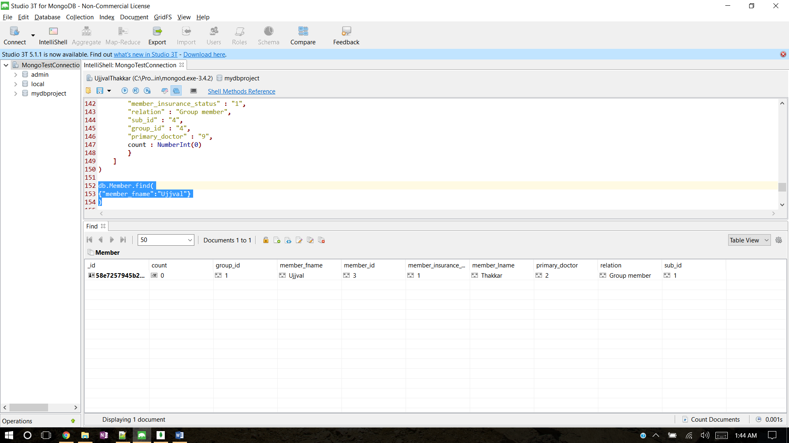

***Update the document and change the name***

db.Member.update({'member_fname':'Ujjval'},{$set:{'member_fname':'Ujjval Thakkar'}})

db.Member.find(

{"member_fname":{$gte:"Ujjval"}}

)

***Explanation:***

First query, Updates the document with fname as “Ujjval” to fname as “Ujjval Thakkar”

The second query, Finds a member with name >= “Ujjval”

$gte => Greater than or equal to (>=)

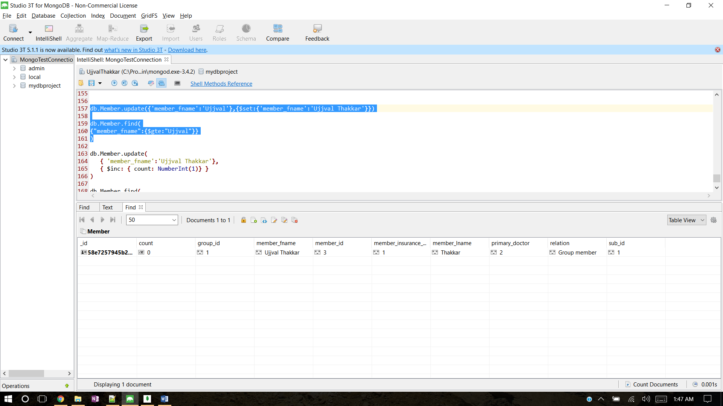

***Update the document again and increment a integer value if you collection doesn't have any integers add one to it and then increment it.***

db.Member.update(

{ 'member_fname':'Ujjval Thakkar'},

{ $inc: { count: NumberInt(1)} }

)

db.Member.find(

{"member_fname":{$gte:"Ujjval"}}

)

***Explanation:***

The first query, increments and adds an Integer value ‘1’ to the existing integer value of ‘count’, which is updated from 0 to 1.

The second query, Finds a member with name >= “Ujjval” and confirms the increment update.

$gte => Greater than or equal to (>=)

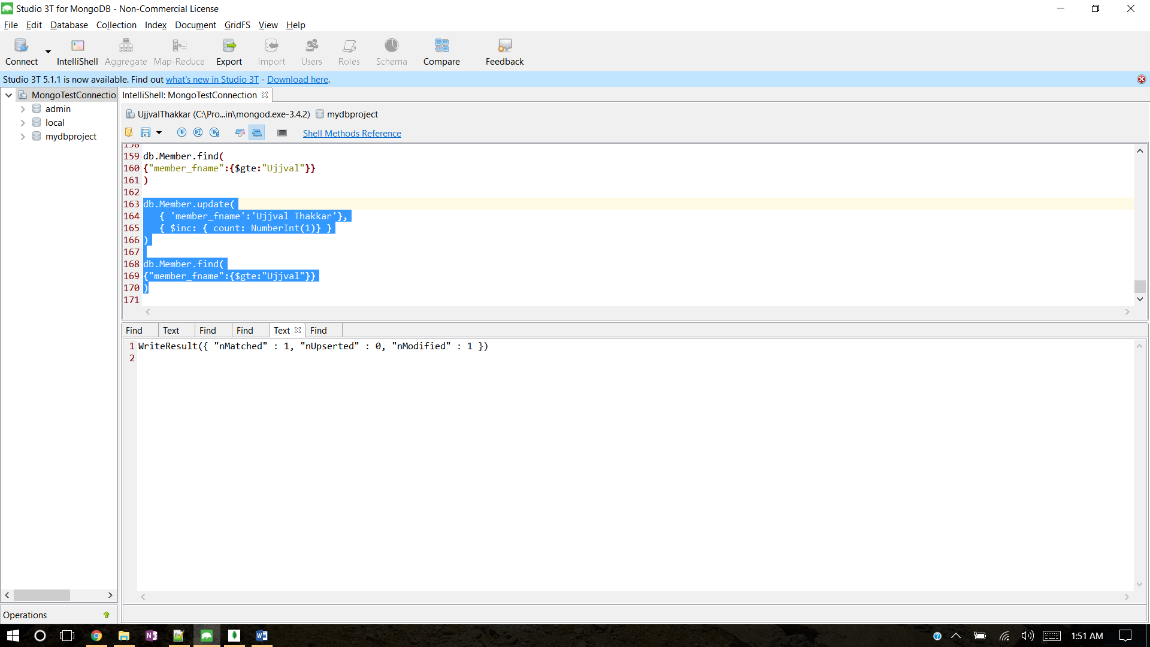

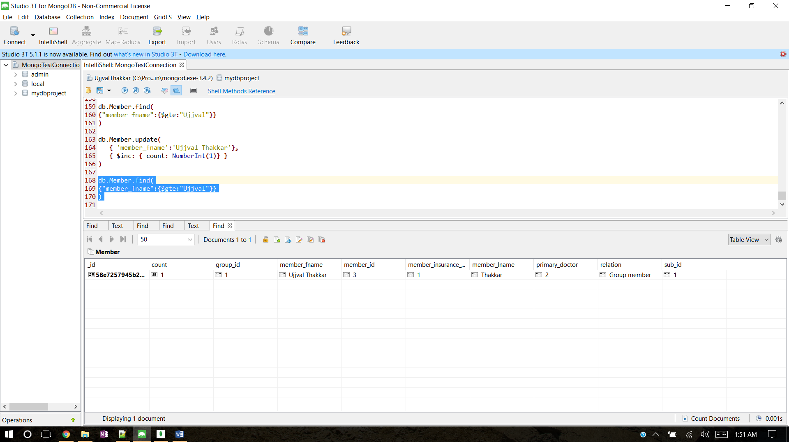

***Explain the difference between save and insert in mongo***

* The save() method replaces the existing document with the new document passed in the save() method.
* To insert data into MongoDB collection, you need to use MongoDB's insert() or save() method.
* To insert the document you can use db.post.save(document) also. If you don't specify _id in the document then save() method will work same as insert() method. If you specify _id then it will replace whole data of document containing _id as specified in save() method.
* If a document does not exist with the specified _id value, the save() method performs an insert with the specified fields in the document.
* If a document exists with the specified _id value, the save() method performs an update, replacing all field in the existing record with the fields from the document.
* For save, If the document contains _id, it will upsert querying the collection on the _id field, If not, it will insert.
* *"****UPSERT****" definition. "UPSERT" is a DBMS feature that allows a DML statement's author to atomically either insert a row, or on the basis of the row already existing, UPDATE that existing row instead, while safely giving little to no further thought to concurrency.*